Date

Global Institute of marketing Pty Ltd TA Short courses Australia
ATP Email Address submission@shortcoursesau.edu.au

Attention TRAFFIC COMPANY Global Institute of Marketing Pty Ltd TA Short Courses Australia wishes to confirm that the employee(s) listed below are currently employed as a utility worker either directly or indirectly meeting the definition below.
The Utilities Temporary Traffic Management (TTM) Worker Accreditation course is designed for all workers employed directly or indirectly by a Utility organisation that provides basic public needs such as water, gas, electricity, communications.
Indirectly refers to companies who solely work to provide services to a provider of electricity, gas, water or communications.

Name of Worker (legal name) | Employee ID

If you have any additional questions please contact:
Name: Administration team | Phone Number: 1300 74 74 30 | Email: info@shortcoursesau.edu.au

Kind Regards,
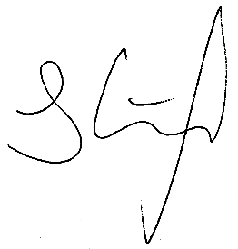
Jonathon Ainscough

Chief Executive Officer

Mobile 0428 690 406
Phone: 1300 74 74 30
Email: jonathon@shortcoursesau.edu.au
Web: www.shortcoursesau.edu.au


